DLD-1 | Caco2
24.06.2026 green team: Line, Lars, Andreas
DLD1
Experiment 1: NaBu dose response

Input: Two 24-well plate.
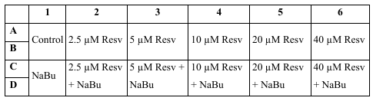

Workflow:
- Do nothing for today. Maybe check cells. It is incubating for Thursday.

Input: Frozen cells
Thawing Workflow:
- Preheat 15 ml pre-heated media (McCoy) in T75 flask.
- Extract cryotube from cry-container. Do not make the tube explode. Transport to lab, e.g. in lab coat pocket.
- Clean cryotube in ethanol. (Can you handle this with regular gloves?)
- Transfer pre-heated media to tube. Resuspend. Repeat until the cells are out.
- Put them incubator.

24.06.2026 green team: Line, Lars, Andreas  DLD-1  Experiment 2a: cell cycle  FACS  Input: 3x treated T75 flasks  Workflow:  - Trypsinize  - Resuspend in 9 ml PBS-EB  - Centrifugate for 5 min at 300g then discard supernatant  - Wash in 10 ml PBS-EB  - Centrifugate 5 min at 300g then n discard supernatant  - Resuspend in 3 ml PBS-EB  - Count cells  - Transfer 500’000 cells to FACS tube fill until 3 ml.  - Generate more tubes if enuff cells  - Centrifugate and discard supernatant  - Resuspend in 200 µl PBS-EB  - Add 2 ml ice-cold 70% ethanol while whirly mixing (vortex).  - Incubate on ice for at least 30 minutes. Keep samples on -20.  - ---- staining step -----------------  - Centrifugate at 300g for 5 min. Discard supernatant.  - Resuspend in 2-3ml PBSw.  - Centrifugate at 300g for 5 min. Discard supernatant  - Resuspend in 400 µl PBSw. Add 50 µl RNAse and 50 µl propidium iodide (use gloves). Incubate at room temperature for 30 min.  - Centrifugate at 300g for 5 min. Discard supernatant.  - Resuspend in 0.5 ml PBSw.  - Analyze by flow cytometry | 24.06.2026 green team: Line Lars Andreas  CaCo-2
24.06.2026 green team: Line, Lars, Andreas
DLD-1 and Caco2:
Experiment 2b:
Hoechst 33342 / Alamar Blue 96 well assays

Do nothing. The plate is incubating. Remember that our plate is a bit wrong and contains both caco and dld1 instead of each on its own plate.

24.06.2026 green team: Line, Lars, AndreasDLD-1:  Experiment 3:  Transfection with linear polyethyleneimine (PEI) and plasmids:  Input: 6 well plate.  Workflow: Change old medium with 4 mL new Medium (McCoy) for each well | 24.06.2026 green team: Line, Lars, Andreas Caco2:  Experiment 3:  Transfer 20 µl to the 96 well plate for the columns for day 3.  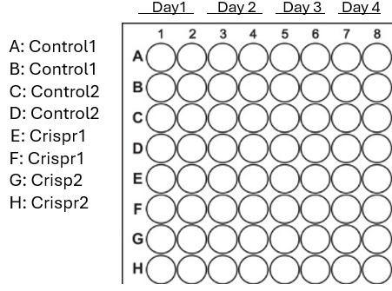
24.06.2026 green team: Line, Lars, Andreas
CaCo-2
Experiment 4:
Data analysis of confocal microscopy images.

